Title (20 size)
(13 size) A Project Based Learning Report Submitted in partial fulfilment of the requirements for the award of the degree

of

Bachelor of Technology
in The Department of XXXX
Course name with Course code

Submitted by
Roll.no: NAME
Roll.no: NAME
Roll.no: NAME

Under the guidance of
XXXX(faculty name)



Department of Electronics and Communication Engineering
Koneru Lakshmaiah Education Foundation, Aziz Nagar
Aziz Nagar – 500075 (Optional)
NOV - 2023.
Abstract
List of Figures

(if any)

List of Tables

(if any)
Table of Contents
Title (Font size 24)
Note: Maintain Document format as it is in terms of font size and font theme.

Introduction
[Note: introduction must be at least 1 page] FOR EXAMPLE: Since it acts as a barrier for other internal systems, the skin2 is more vulnerable to disease despite being the largest organ in the human body.1 In 2018, melanoma was the most common malignant tumour in both men and women, with over 300,000 new cases identified worldwide.3 Around a million new cases of the more deadly skin cancers basal cell carcinoma (BCC) and squamous cell carcinoma (SCC) were diagnosed in 2018, making 2018 a very bad year for skin cancer overall. According to,4 skin cancer accounts for more new cases in the United States than all other types of cancer put together. The good news is that early detection increases the likelihood of afull recovery. Whenmelanoma has notmigrated to other parts of the body, the 5-year survival rate is around 100%. If cancer spreads to other organs, the chance of survival reduces to 20%. Yet, because the first signs of skin cancer aren’t usually obvious, a dermatologist’s expertise5 is often crucial to making an accurate diagnosis.

METHODOLOGY

Selecting a Template (Heading 2)
[For example] The three subtypes of skin cancer cannot be accurately categorized using simple and straightforward CNN. To facilitate the categorization of fine-grained classification, we are therefore attempting to select certain early and intermediate traits as well. A benchmark data set for cancer is used to evaluate the convolution neural network (CNN) trained using alternating sequential and residual phases. As can be seen in Figure 1, the classification approach in this work has dealt with three distinct models. In order to build the proposed classification model, CNN is utilized. There is an input layer, a flattened layer, a dense layer, and an output layer, as well as hidden layers (transitional model) 2.2. Each of the six hidden layers here consists of Conv2D, Batch-Normalization, MaxPool2D, and Dropout layers, making up the transitional model 2.2. When there are too many convolution layers, the model’s accuracy declines because the gradient tends to zero, and the deep layers can’t learn anymore.
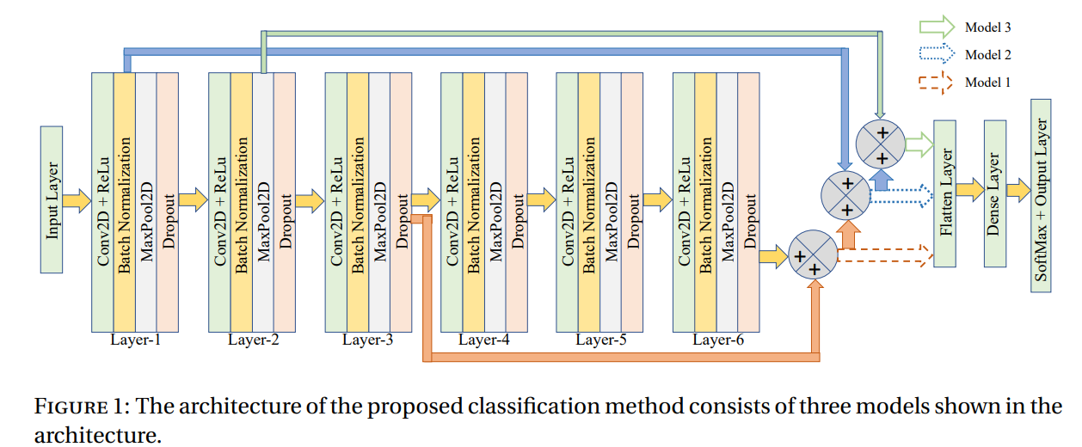

EXPERIMENTS
[For Examples]

[For example] The primary goal is to examine the skin cancer types’ fine-grained classification. Based on the similarities that Basal Cell Carcinoma (BCC), Benign Keratosis-like Lesion (BKL) (solar lentigines / Seborrheic Keratoses and Lichen-planus-like Keratoses), and Melanoma(MEL) have, we considered these three classes. For the training and evaluation process, we have considered 1113 images of MEL class, 1099 images of BKL class, and 725 images of the BCC class. MEL and BKL classes images were obtained directly from the HAM10000 database: HARVARD Dataverse provides access to the HAM10000 opensource data set. At the same time, 80% of the BCC data were acquired from the HAM10000 database and 20% from other resources. Figure 2 illustrates the different skin cancer types, as stated above. The first, second, and third rows show images of BCC, BKL, and MEL, respectively.
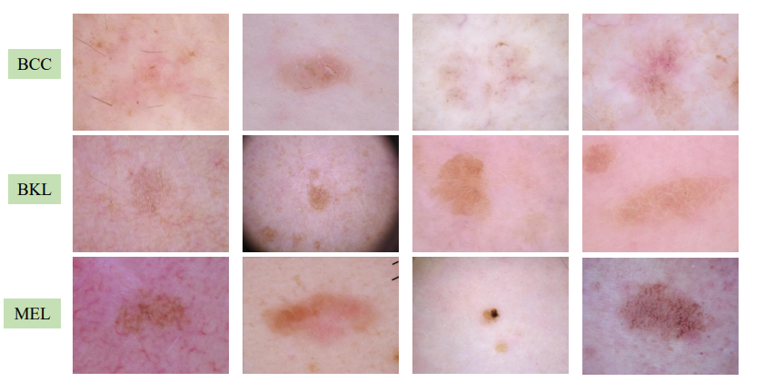
Keep your text and graphic files separate until after the text has been formatted and styled. Do not use hard tabs, and limit use of hard returns to only one return at the end of a paragraph. Do not add any kind of pagination anywhere in the paper. Do not number text heads-the template will do that for you.

RESULTS
[For Examples]

[For example] Further, we have compared the performance of model 1, model 2, model 3, and VGG-16 in terms of accuracy as depicted in Table 1. Table 1 shows that model 3 performed better with an accuracy of 74%. The confusion matrix of model 3 is shown in Table 2. From these results, it is clear that the accuracy
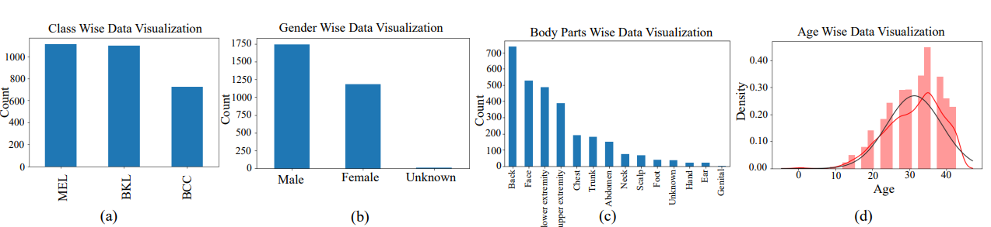

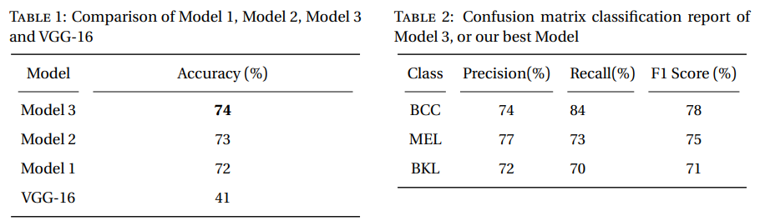

CONCLUSION and FUTURE WORK
[For Examples]

The In this paper, we proposed a novel CNN model for the fine-grained classification of skin cancer to address this issue. We discovered that to classify the fine-grained classification problem, it is necessary to consider not only the essential features from the final layer of the model but also the features from the early layers and the features from the intermediate layers. This helps to make the model more accurate and robust. In the future, one of our primary goals will be to build a model that is both more accurate and reliable in terms of fine-grained skin cancer classification.

References
[For Examples]

- G Swann, "EDITORIAL," Journal of Visual Communication in Medicine, 33, 148-149 (2010) DOI: 10.3109/17453054.2010.525439.
- William Montagna, and Paul F. Parakkal, [The Structure and Function of Skin], ACADEMIC PRESS, INC. A subsidiary of Harcourt Brace Jovanovich, Publishers 2012, (third edition)).
- Evangeline Samuel, Maggie Moore, Mark Voskoboynik, Mark Shackleton, and Andrew Haydon, "An update on adjuvant systemic therapies in melanoma," Melanoma Manag, 6, 2045-0893, 2019.
Howard W Rogers, Martin A Weinstock, Steven R Feldman , and Brett M Coldiron, "Incidence Estimate of Nonmelanoma Skin Cancer (Keratinocyte Carcinomas) in the U.S. Population, 2012," JAMA Dermatol., 151, 1081-6, 2015.

